Project Report

On

**WINDOWS 11 UI**

For The Course: **WEB TECHNOLOGIES**

**(ISOE11)**

By

**SALIQ ARSHID (1MS20EC090)**

**S.N.CHARAN (1MS20EC083)**

DEPARTMENT OF ELECTRONICS AND COMMUNICATION ENGINEERING

RAMAIAH INSTITUTE OF TECHNOLOGY

BANGALORE – 560054

TERM: **2022-2023**



**INDEX**

* ACKNOWLEDEGEMENT
* TITLE OF THE PROJECT
* LANGUAGE AND SOFTWARE TOOL USED
* SYNOPSIS /INTRODUCTION
* CODE SNIPPETS
* RESULT/SCREENSHOTS

**ACKNOWLEDEGEMENT**

We would like to express our special thanks of gratitude to our teacher **Dr. Sumana Maradithaya** who gave us the golden opportunity to do this wonderful project on the topic of **Windows 11 User Interface** which helped us to understand the concepts of HTML, CSS and Javascript and also helped us to implement those concepts in real world projects.

**DATE: 13/12/2022 SALIQ ARSHID (1MS20EC090)**

1. **N. CHARAN (1MS20EC083)**

**Department of Electronics &**

**Communication**

**TITLE OF THE PROJECT**

WINDOWS 11 UI

**LANAGUAGE AND SOFTWARE TOOL USED**

FRONT END - HTML,CSS AND JAVASCRIPT

CODE EDITOR - VS CODE

**SYNOPSIS /INTRODUCTION**

The website basically consists of two pages - Login Page and Desktop.

**Login Page**

We have created a website consisting of a login page that asks the user for login information like username and password. After the user presses login he/she logs in to the UI of Windows 11.

**Desktop**

Here on the desktop, we have added a few icons like This PC, Recycle Bin, Microsoft Edge, VLC Media Player. There is a taskbar at the bottom of the page consisting of several icons. Once the user presses on an icon present in the taskbar, a window pops up according to a particular transition that is specific to the icon pressed either from the top, bottom or the side same as in the user interface of Windows 11.

We have used HTML to form the basic layout of the web page and CSS to style the web page and align the various parts of the web page. Apart from CSS and HTML, we have used addEventListener() method of Javascript to pop up different windows when a user clicks on different icons present in the taskbar.

**CODE SNIPPETS**

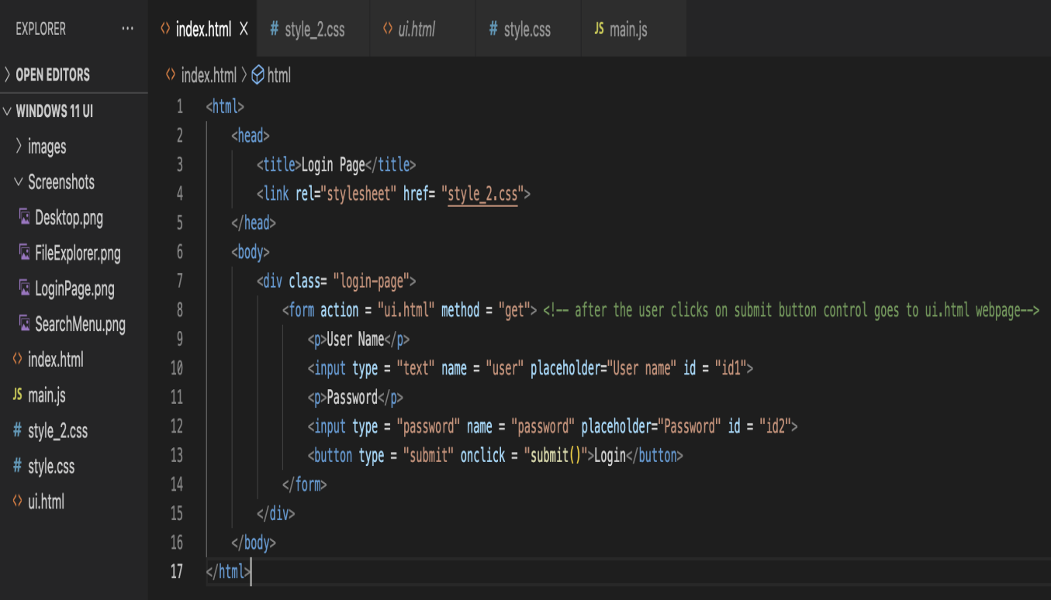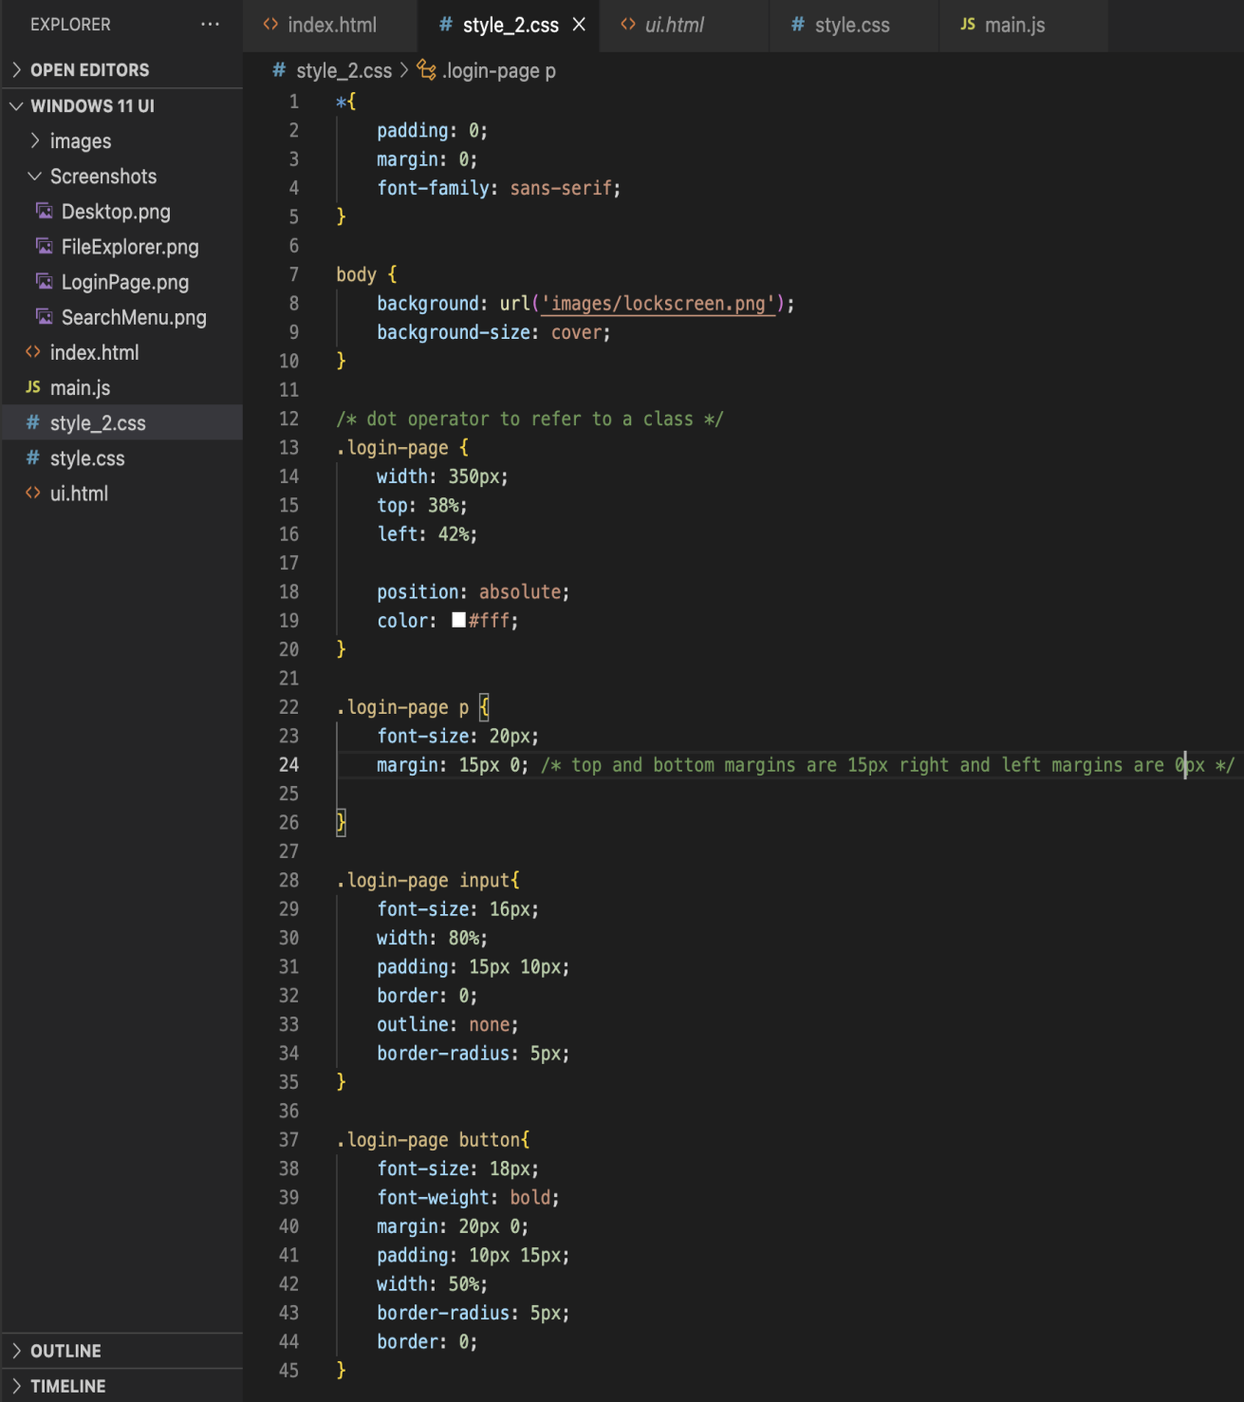

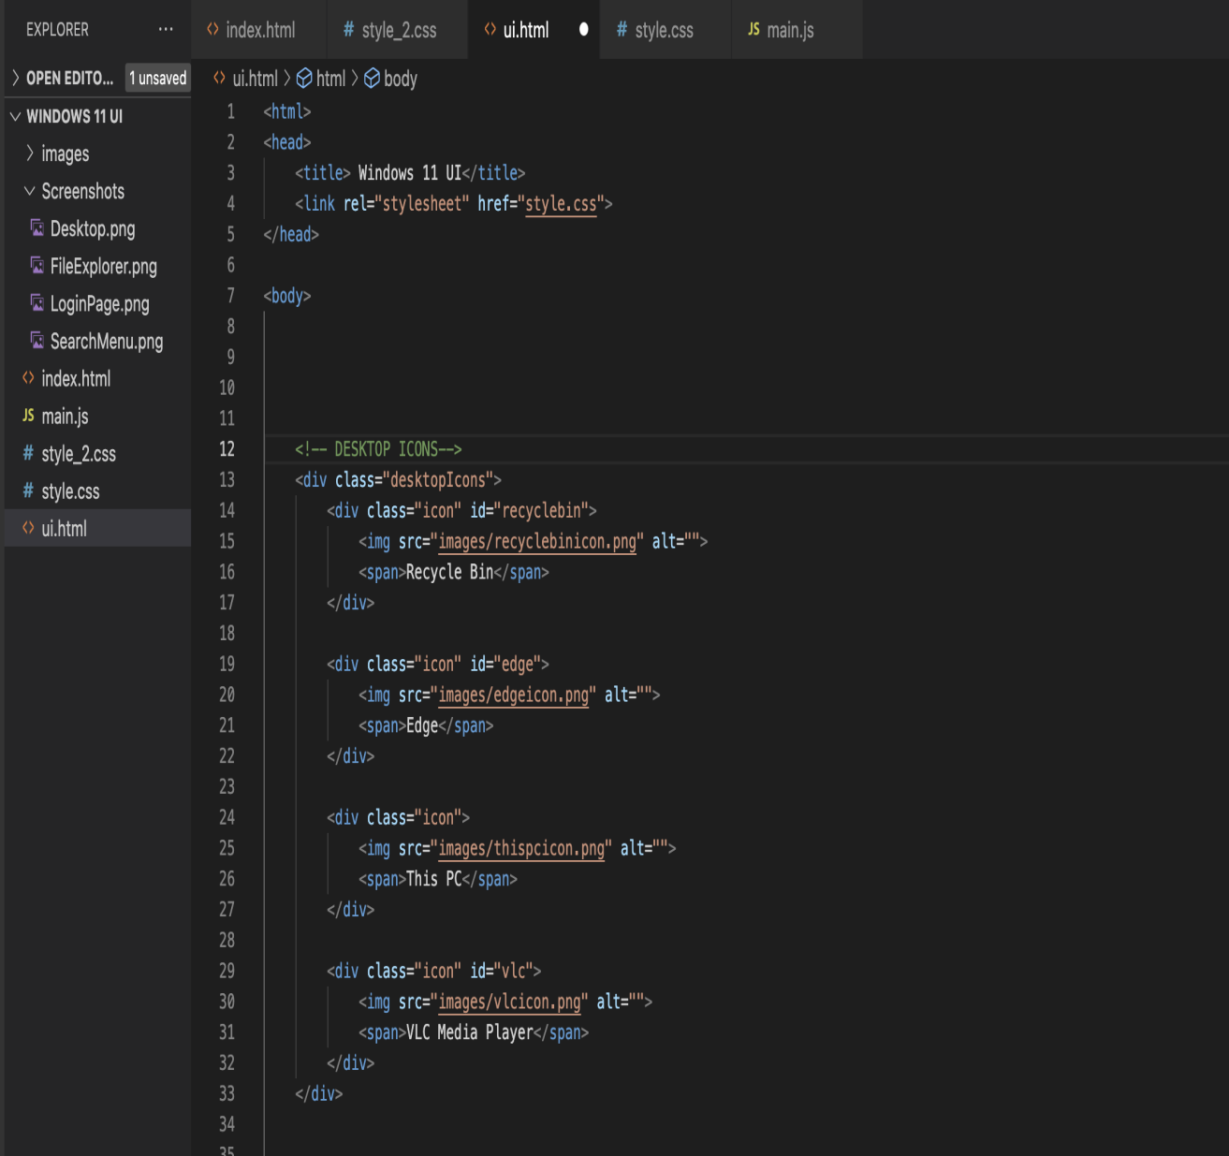

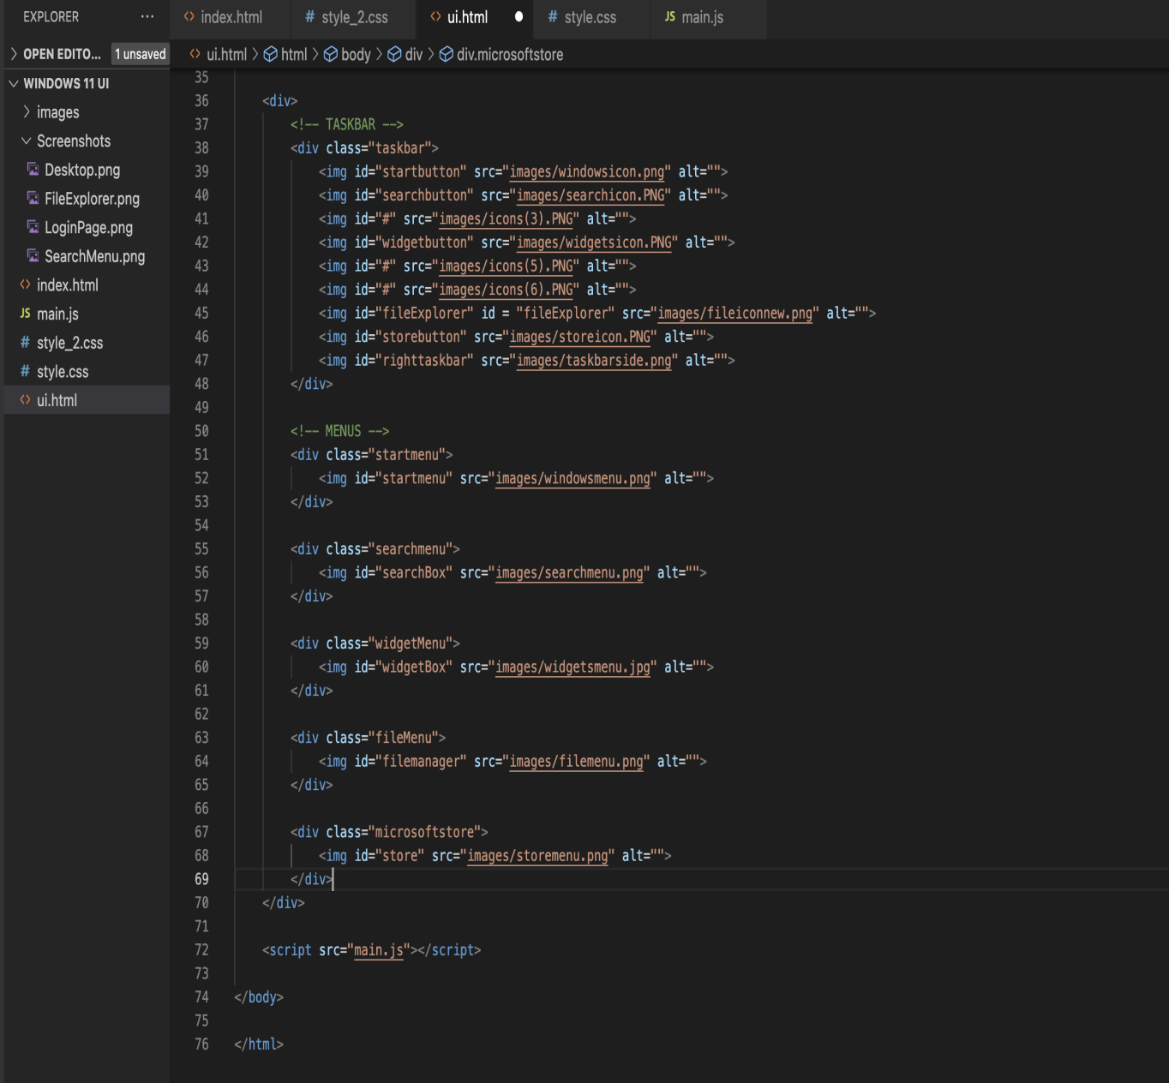

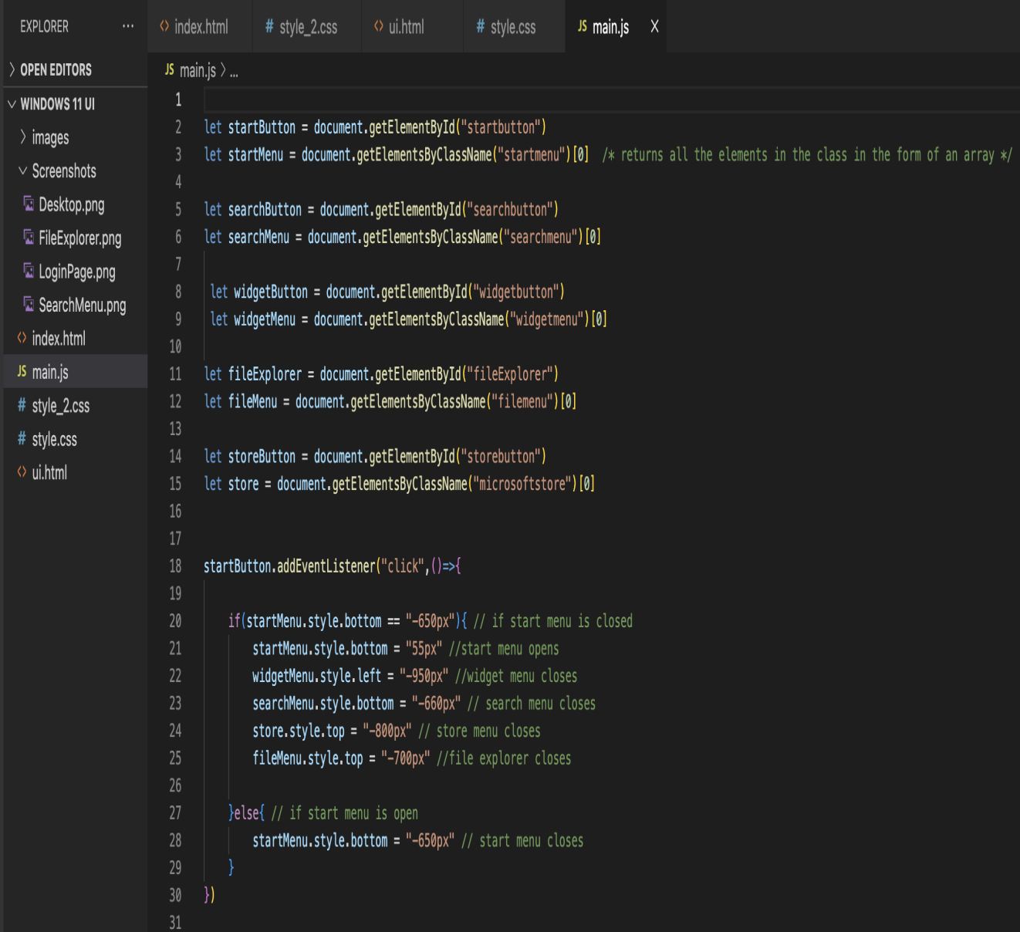

**RESULT/SCREENSHOTS OF THE WEBSITE**

